1. select COUNT(id) as Total_Applications from bank_loan_data

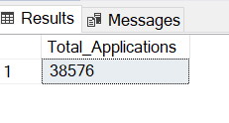

1. Select COUNT(id)AS MTD_loan_Application from bank_loan_data

where MONTH(issue_date)=12 AND YEAR(issue_date)=2021

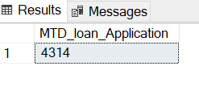

3.Select SUM(loan_amount)as MTD_total_funded_amount from bank_loan_data

where MONTH(issue_date)=12 and YEAR(issue_date)=2021

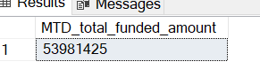

4.Select SUM(loan_amount) as PMTD_total_funded_amount from bank_loan_data

where MONTH(issue_date)=11 and YEAR(issue_date)=2021

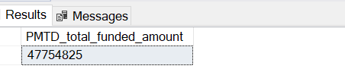

5. Select SUM(total_payment) as total_payment_received from bank_loan_data

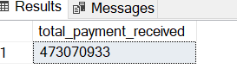

6. Select SUM(total_payment) as MTD_total_payment_received from bank_loan_data

where MONTH(issue_date)=12 and YEAR(issue_date)=2021

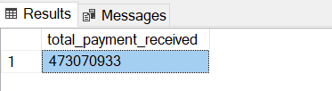

7. Select SUM(total_payment) as PMTD_total_payment_received from bank_loan_data

where MONTH(issue_date)=11 and YEAR(issue_date)=2021

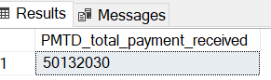

8. SELECT ROUND(AVG(int_rate),4)*100 AS MTD_Avg_interest_rate from bank_loan_data

WHERE MONTH(issue_date)=12 and YEAR(issue_date)=2021

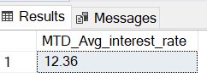

9.SELECT ROUND(AVG(dti),2)*100 as Avg_DTI FROM bank_loan_data

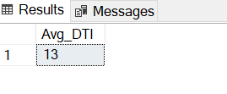

10.SELECT ROUND(AVG(dti),4)*100 as MTD_Avg_DTI FROM bank_loan_data

where MONTH(issue_date)=12 and YEAR(issue_date)=2021

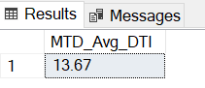

11. SELECT ROUND(AVG(dti),4)*100 as PMTD_Avg_DTI FROM bank_loan_data

where MONTH(issue_date)=11 and YEAR(issue_date)=2021

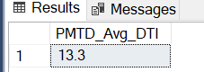

12.Select

(COUNT(CASE WHEN loan_status ='Fully paid' OR loan_status='Current' THEN id END)*100)

/

COUNT(id) AS Good_loan_percentage

from bank_loan_data data

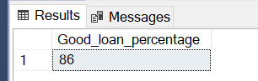

12. SELECT COUNT(id) as Good_loan_application from bank_loan_data

where loan_status='Fully paid' or loan_status='Current'

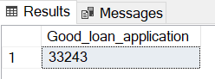

13.SELECT SUM(loan_amount) as Good_loan_funded_amount from bank_loan_data

where loan_status='Fully paid' or loan_status='Current'

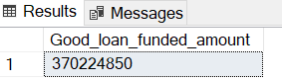

14. SELECT SUM(total_payment) as Good_loan_recieved_amount from bank_loan_data

where loan_status='Fully paid' or loan_status='Current'

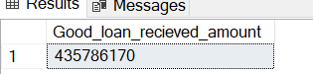

15.SELECT

COUNT(id) as Total_loan_appication ,

SUM(loan_amount) as Total_funded_amount,

SUM(total_payment) as Toatl_payment_recieved,

AVG(dti*100 )as DTI,

AVG(int_rate) as avg_interest_rate

from bank_loan_data

group by loan_status

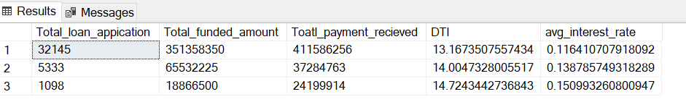

16. SELECT

loan_status ,

SUM(loan_amount) as MTD_funded_amount,

SUM(total_payment) as MTD_payment_recieved,

AVG(dti*100 )as DTI,

AVG(int_rate) as avg_interest_rate

from bank_loan_data

WHERE MONTH(issue_date)=12

group by loan_status

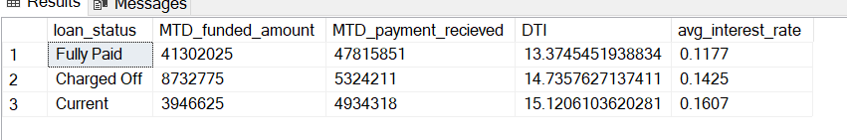

17. SELECT

DATENAME(MONTH,issue_date),

COUNT(id) as Total_loan_appication ,

SUM(loan_amount) as Total_funded_amount,

SUM(total_payment) as Toatl_payment_recieved

from bank_loan_data

group by DATENAME(MONTH,issue_date)

ORDER BY DATENAME(MONTH,issue_date)

